Youth Council Viewing Submitted Applications Documentation

- Navigate to the Wix dashboard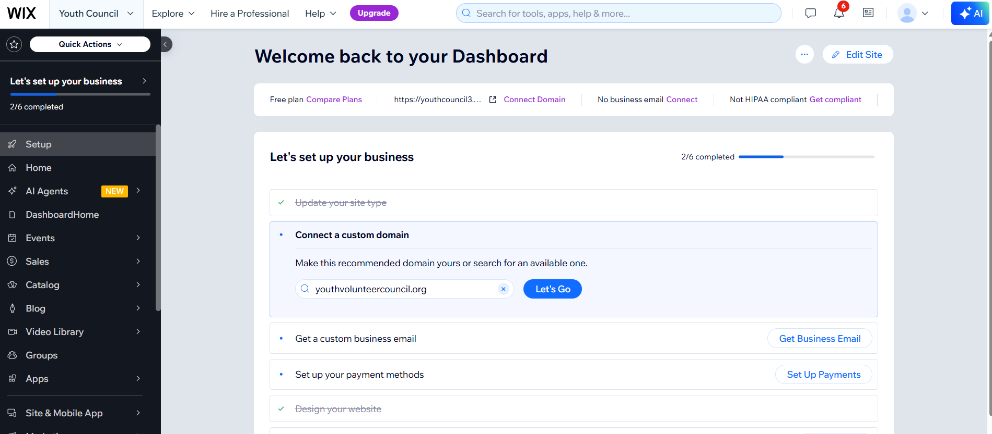
- Scroll until you see “Customers and Leads”, then click on “Forms and Submissions”
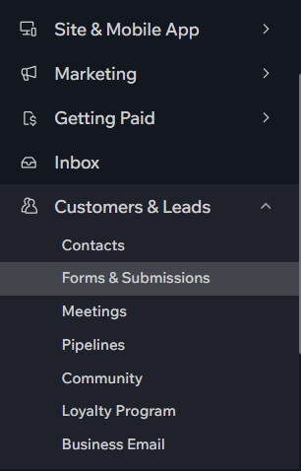
- Click the number of submissions to view the form submissions on the dashboard
